**PROBLEM STATEMENT 1 Find out what are the top 5 categories with maximum number of videos uploaded.**

**DRIVER**

**In driver set the task,job configuration and Input and Output format**

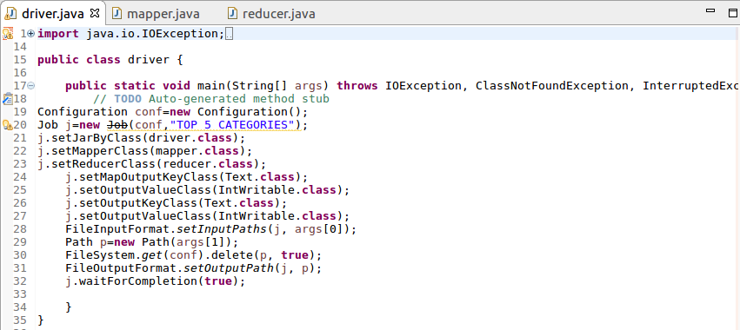

**Mapper**

**Since we want the top 5 categories split the data and then send category as key and a count of 1 as value**

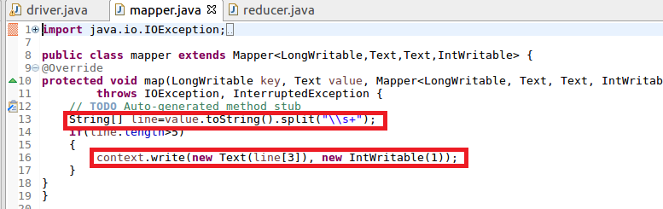

**Reducer**

**In reducer,the total count for each category is made by the iterating values**

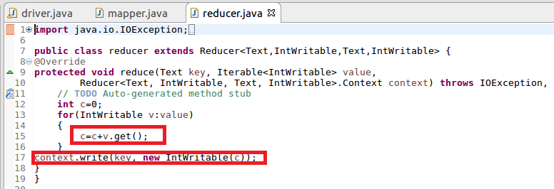

**Running jar**

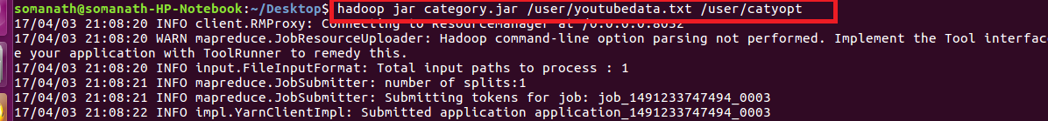

**Output:**

**Since we want top 5 categories we can use sort –n –k2 –r |head –n5 where k2 represents the 2 column (value column)based on which sorting should be done and the -r is used for sorting in recursively(reverse order) and head –n5 gives the top 5**



**PROBLEM STATEMENT 2 Find the top 10 rated videos in youtube**

**Driver**

**In driver set the task,job configuration and Input and Output format**

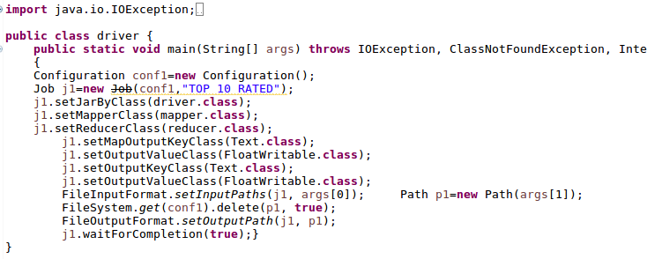

**Mapper**

**Since we want the top 10 rated videos split the data and then send video as key and a rating as value**

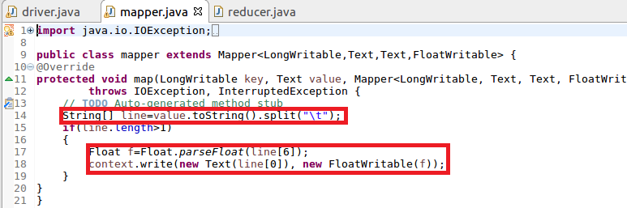

**Reducer**

**In reducer we will sum the rating for each video and find the average rating for each video**

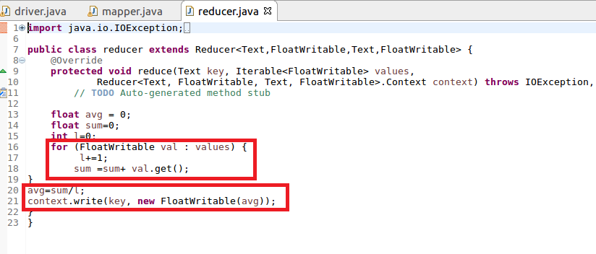

**RUNNING JAR**

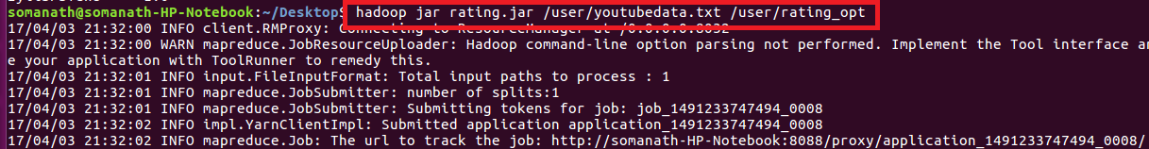

**Output**

**Since we want top 10 ratings we can use sort –n –k2 –r |head –n10 where k2 represents the 2 column (value column)based on which sorting should be done and the -r is used for sorting in recursively(reverse order) and head –n10 gives the top 10**

